Imad assignment 2



Table of Contents

Introduction 3

Main Application 3

The widgets 4

The different actions are shown when each button is clicked 10

References 11

# Introduction

Created a Tamagotchi app that a user is able to interreact with that shows the different actions that the Tamagotchi animal is able to do when the specific button is pressed .The animals actions will change depending on which button you press .The animal that I chose was a tigers cuba

# Main Application

The purpose of this tamagotchi app is a game that users are allowed to experience where they can play feed or clean their play animal .It is a game that is smiliar deisgn to the popluar game Talking Tom but is way easier . deisgn choice . this Tamagotchi app has a simple design choice .The main reason for the design choice is because the app is supposed to be simple for the user to use .Its an app for people who love tiger cubas .The reason I chose a tiger cub is a lot of people that use the Tamagotchi app is find cubs adorable.the deisgn choice informs the user before hand on what they’ll be doing and which animal will they will be playing with .

# The widgets

The main widgets that were used in this code is the button,imageview,textview the button was used to create the action the imageview for the pictures and the textview for the instruction text to help the user interact with the application A simple design choice .When the user cicks the happy button then the progress bar increases until the tiger cub is satified same with the hunger button once you clck the button the cub will eat until its ful giving the a message will pop up and inform the user that the animal is full and no longer hungry .the animal will feel dirty then the

user will have to bath the animal until its clean and then the animal eill be happy and satified

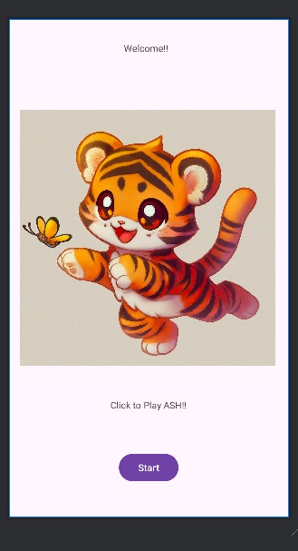

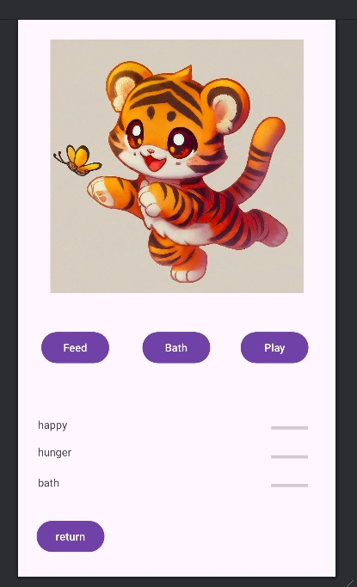

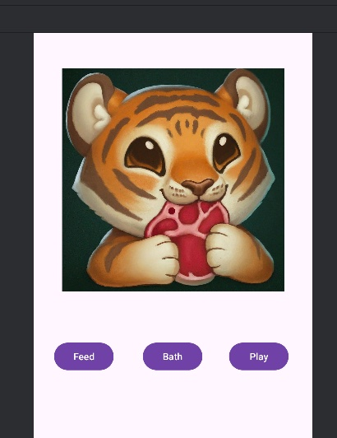

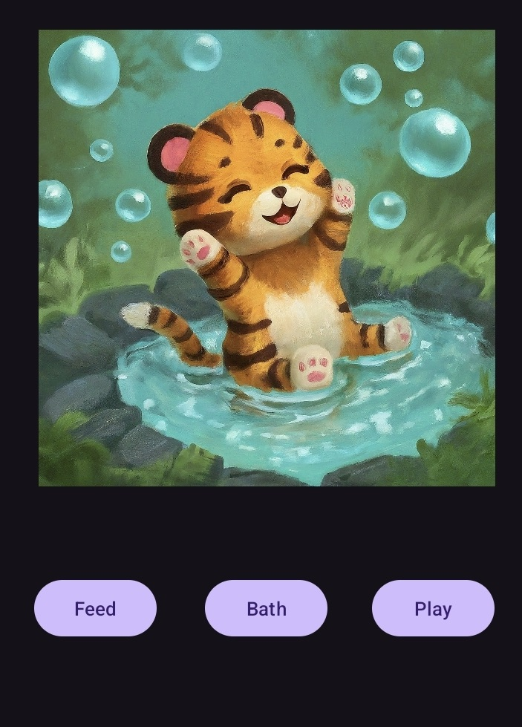

# The different actions are shown when each button is clicked

As it is shown from the pictures when the feed button is clicked an action is shown of the cub eating meat then the progressbar will start from 0 to 100 to tell the user that the animal is full and wont want to eat anymore

The second image shows that when the play button is clicked the cub will start to chase the butterfly around and lastly when the bath button is clicked the cub will be seen in the bathing

# References

<https://pin.it/4YZIMMnfK>

<https://pin.it/FNUHUBCmS>